**ADTA 5900_5750.501_Applied Natural Language Processing_ Assignment 3**

**Yog Chaudhary**

11727095

ADTA 5750 Applied Natural Language Processing

Professor: Dr. Thuan L Nguyen

University of North Texas **Oct 09, 2024**

**4. PART I: Midterm Assessment Information (5 Points)**

Answer the following questions:

**1. How many sections (or parts) are there for the midterm assessment?**

There are three section or parts for the midterm assessments

2. Which sections are take-home assignments that the student will work on them at home?

There are three parts of assignments

* HOMEWORK_ADTA5900_5750_501_assignment_1_2024_FALL.pdf
* **HOMEWORK_ADTA5900_5750_501_assignment_2_2024_FALL.pdf**
* **HOMEWORK_ADTA5900_5750_501_assignment_3_2024_FALL.pdf**

**3. When will MIDTERM ASSESSMENT: PART I & II be assigned?**

* The Midterm assessments parts PART I & II will be assigned are 7 Oct 2024 at 8 am.

**4. When will MIDTERM ASSESSMENT: PART I & II be due?**

* The Midterm assessments parts PART I & II will be assigned are 7 Oct 2024 at 8 am. To 9 Oct 2024

**5. Which sections will the student take in-person in class?**

* The sections will the student take in-person in class of parts MIDTERM_ADTA5900_5750_501_assignment_2024_FALL_PART_I_II.pdf assigned are 7 Oct 2024 at 5:30 pm.

**6. When will the student take MIDTERM ASSESSMENT: PART III in-person in class?**

* The student takes MIDTERM ASSESSMENT: PART III in-person in class are 7 Oct 2024 at 5:30 pm. To 7:50 Pm

**5. PART II: Access and Read Code Lab Tutorials on Dialogflow CX (15 Points)**

**We have done Access and read the tutorials on GCP: Dialogflow CX to build a virtual retail agent.**

**Clink on link** [**https://codelabs.developers.google.com/codelabs/dialogflow-cx-retail-agent#0**](https://codelabs.developers.google.com/codelabs/dialogflow-cx-retail-agent#0)

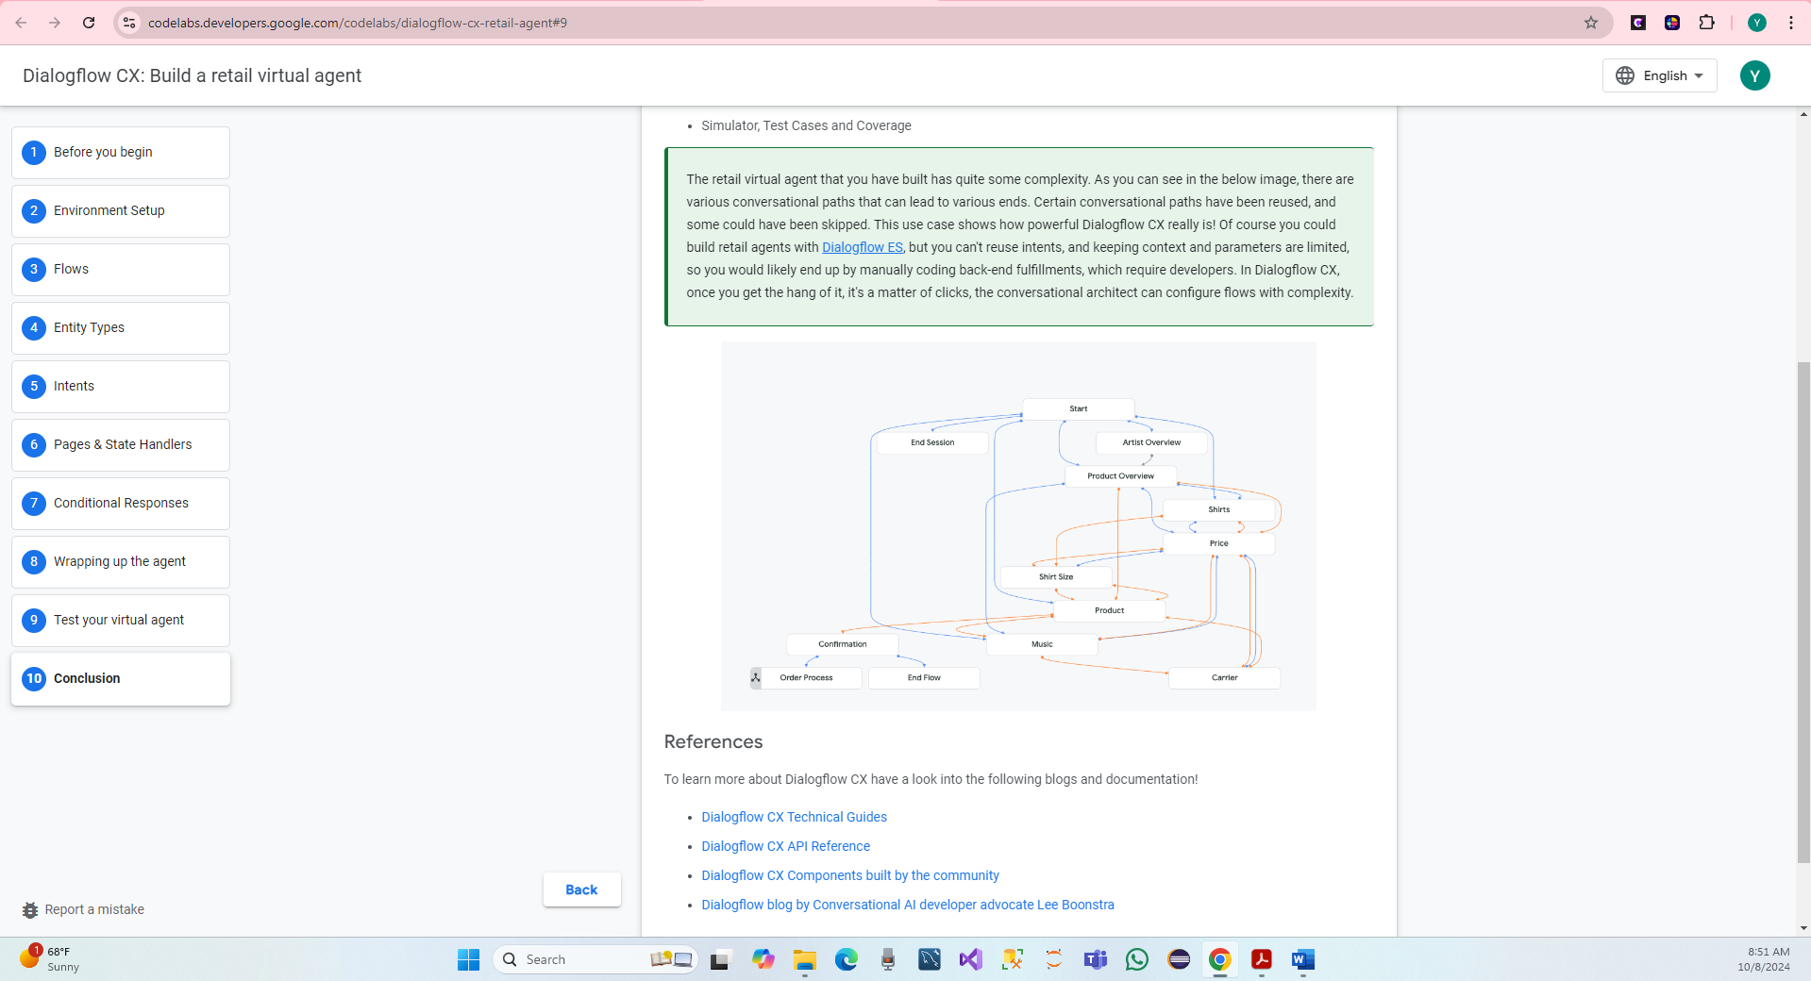

**6. PART III: Develop Conversational AI System for G-Records (70 Points)**

We have a new virtual retail agent for G-Records in Dialogflow CX involves several steps.

Step 1: Access Dialogflow CX

* Go to the Google Cloud Console.
* Long in Google account
* Click on link: <https://cloud.google.com/dialogflow/cx/docs>

We have Navigate to Dialogflow CX in the Google console, Click the hamburger menu in the top left corner

* Got to Artificial Intelligence > Dialogflow
* Click on go to the Dialogflow CX Console.
* Continues on select project name yogchaudharyadata5750

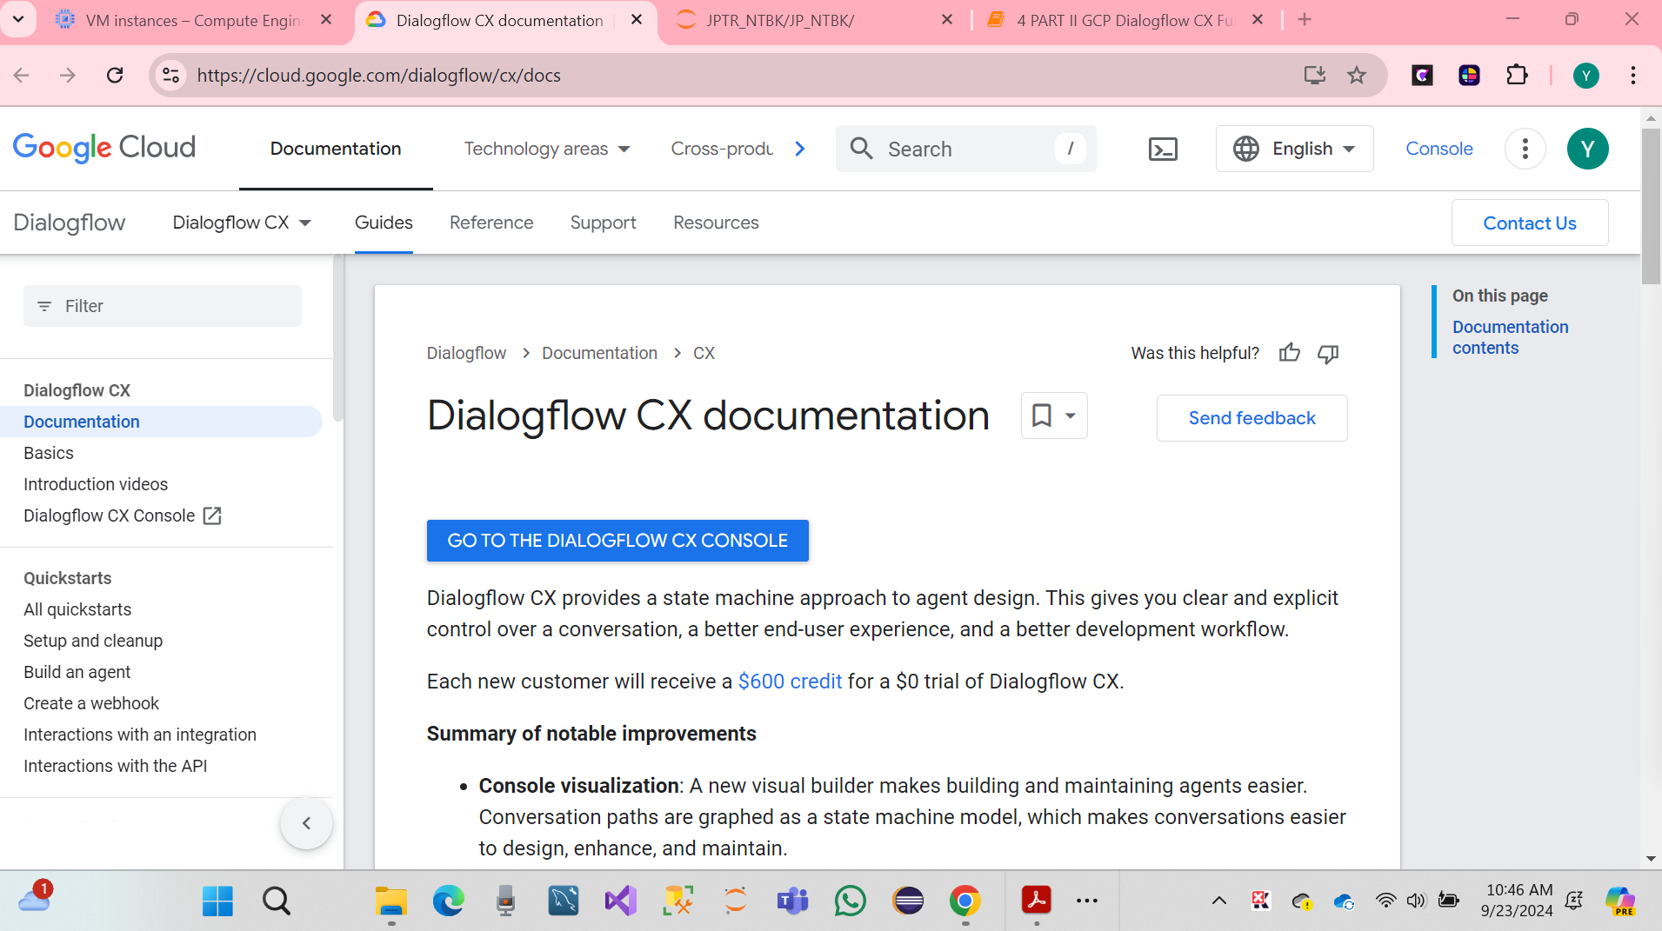

* Click om Enable API.

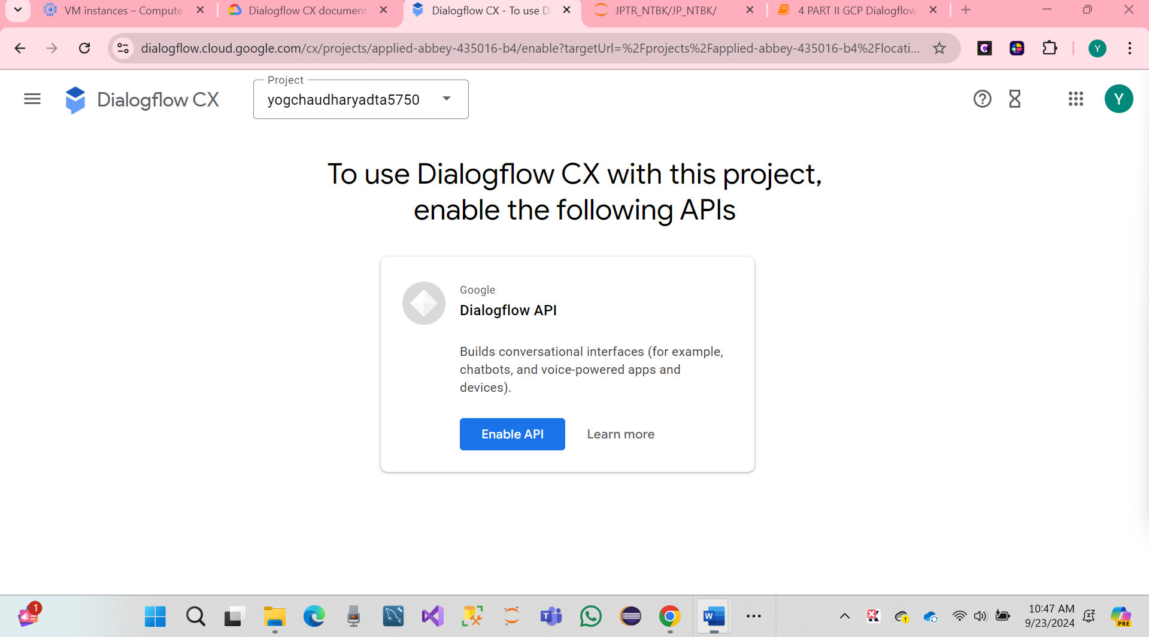

* Click on continues Create agent.

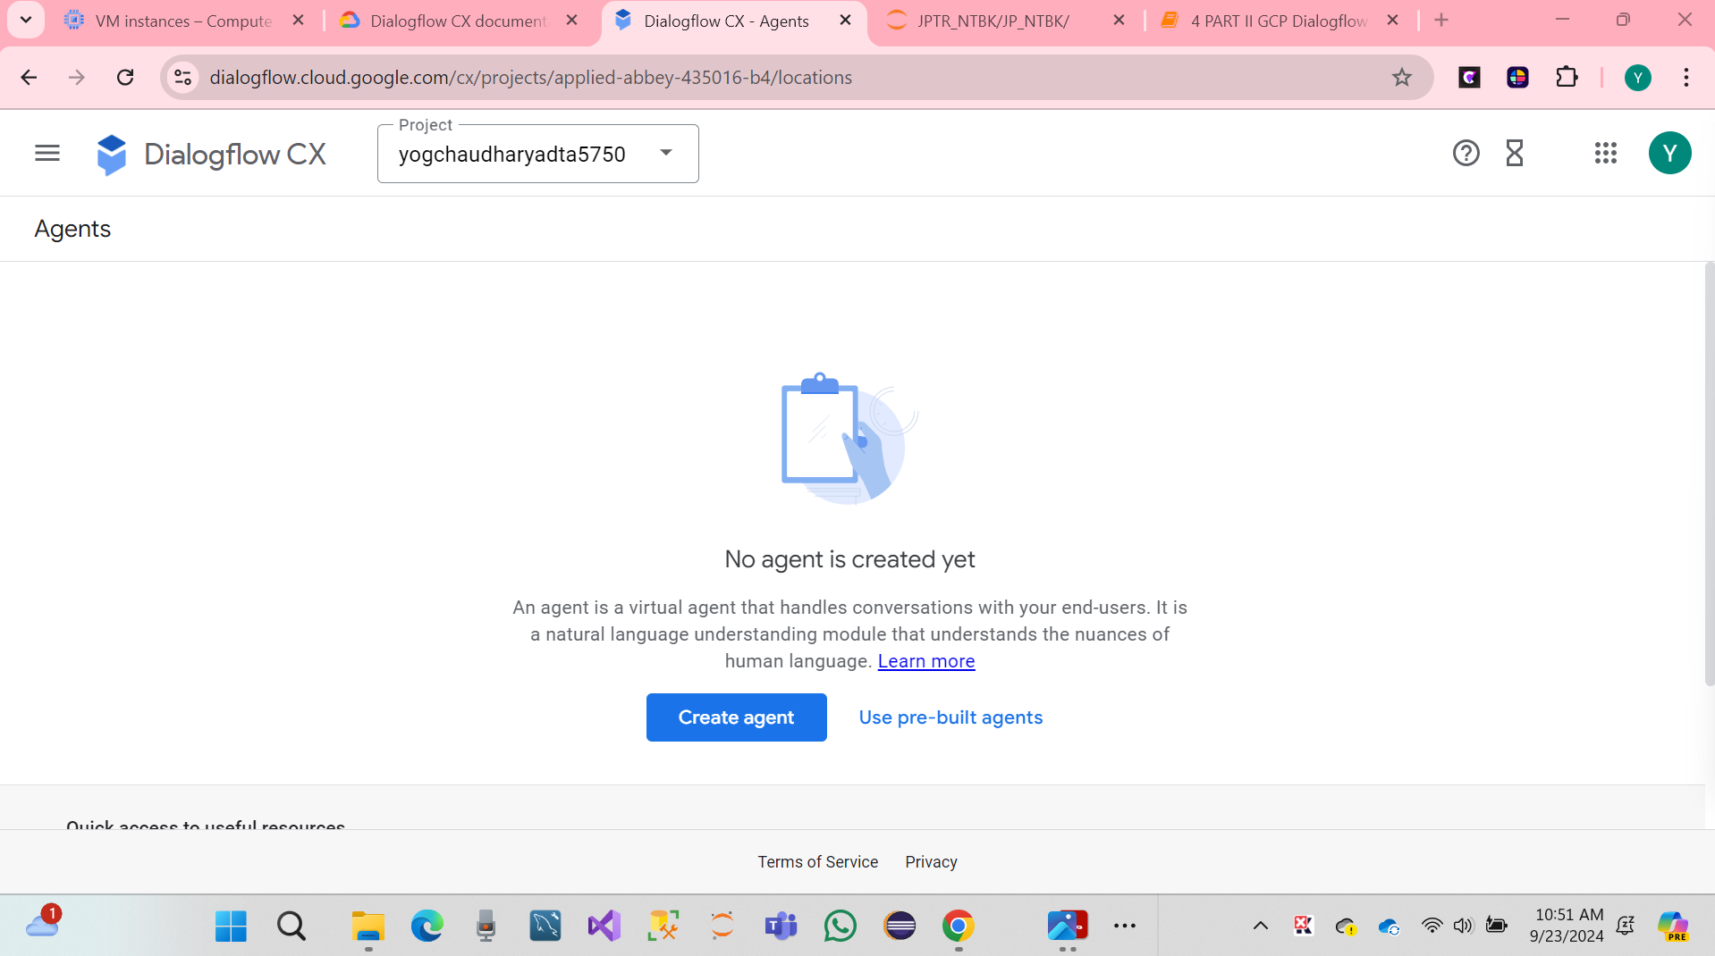

* Hare Screenshot.
* Click on build your own.

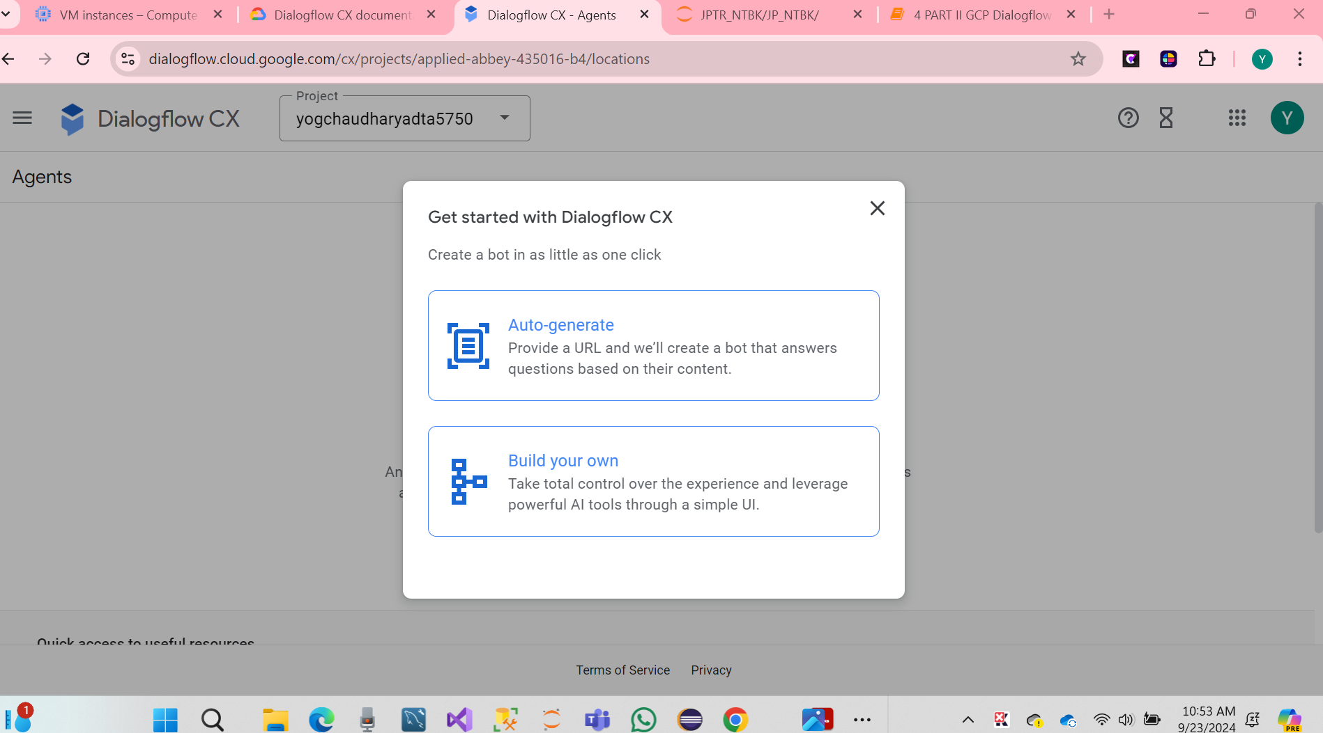

* Click on Build your own.

**Step 2:**

**We have click on the link** <https://dialogflow.cloud.google.com/cx/projects/applied-abbey-435016-b4/locations>,

This project was to design a customer-agent conversation flow for a **"G-Records Retail Agent"**, using Google Dialogflow CX.

* Click on Create new agent button page.
* Name of Agent "G-Records Retail Agent".
* Choose the default language for English.
* Select on the time zone.

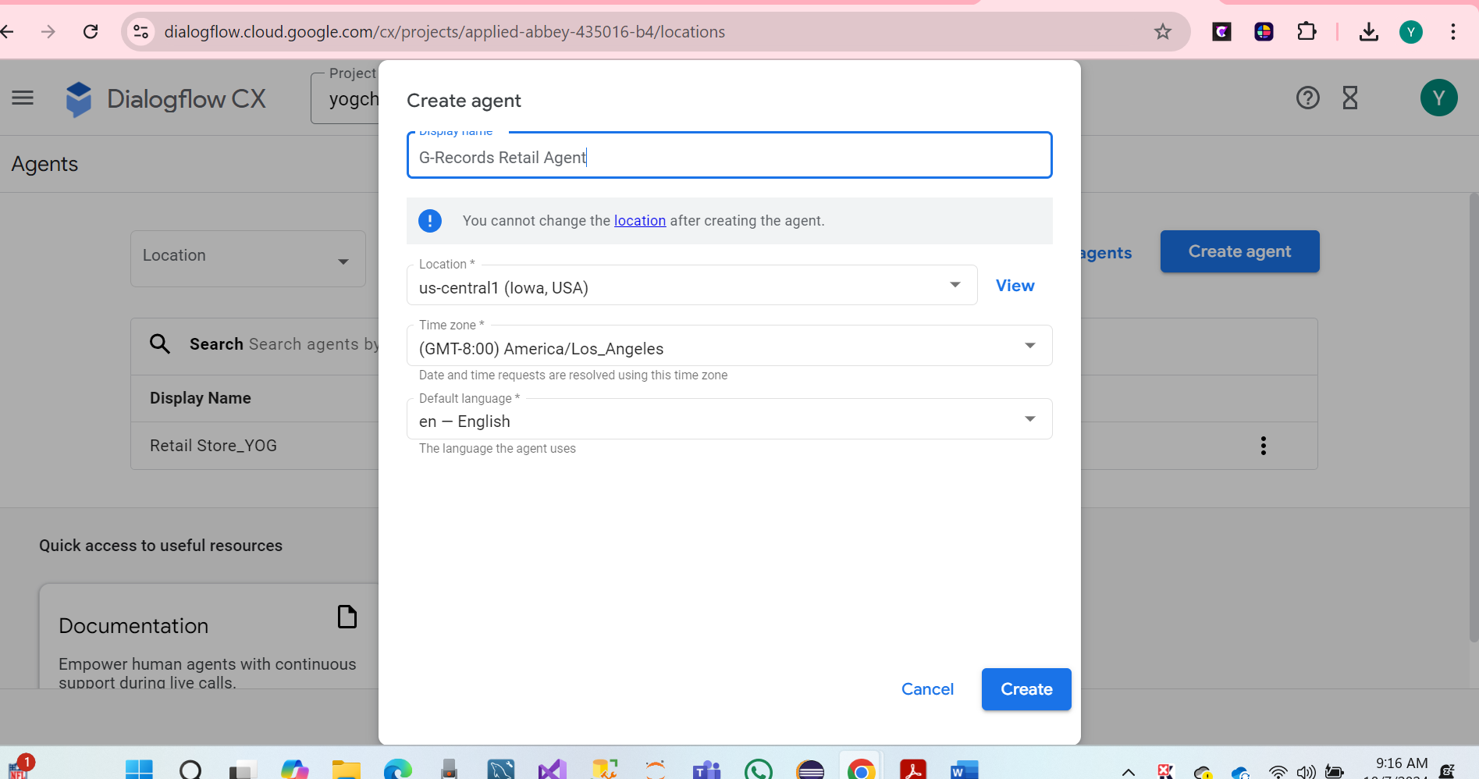

* Click on Create.
* Hare Screenshot below.

We have created agent has been successfully.

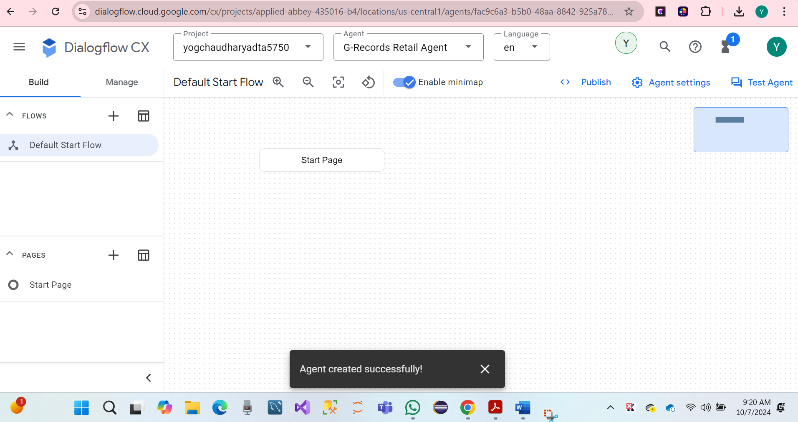

Then, we have verified the Creation of the check Agent Dashboard. After we can see various options create Dialog Flows, Intents, and Entities.

**TO-DO #2 Next, complete the steps to add the flows to the conversational AI system.**

We have Created Flows in Click on Dialogflow CX at Link

<https://dialogflow.cloud.google.com/cx/projects/applied-abbey-435016-b4/locations/us-central1/agents/fac9c6a3-b5b0-48aa-8842-925a786e1fee/flows/00000000-0000-0000-0000-000000000000/flow_creation>

We have also name of Catalog and hit enter.

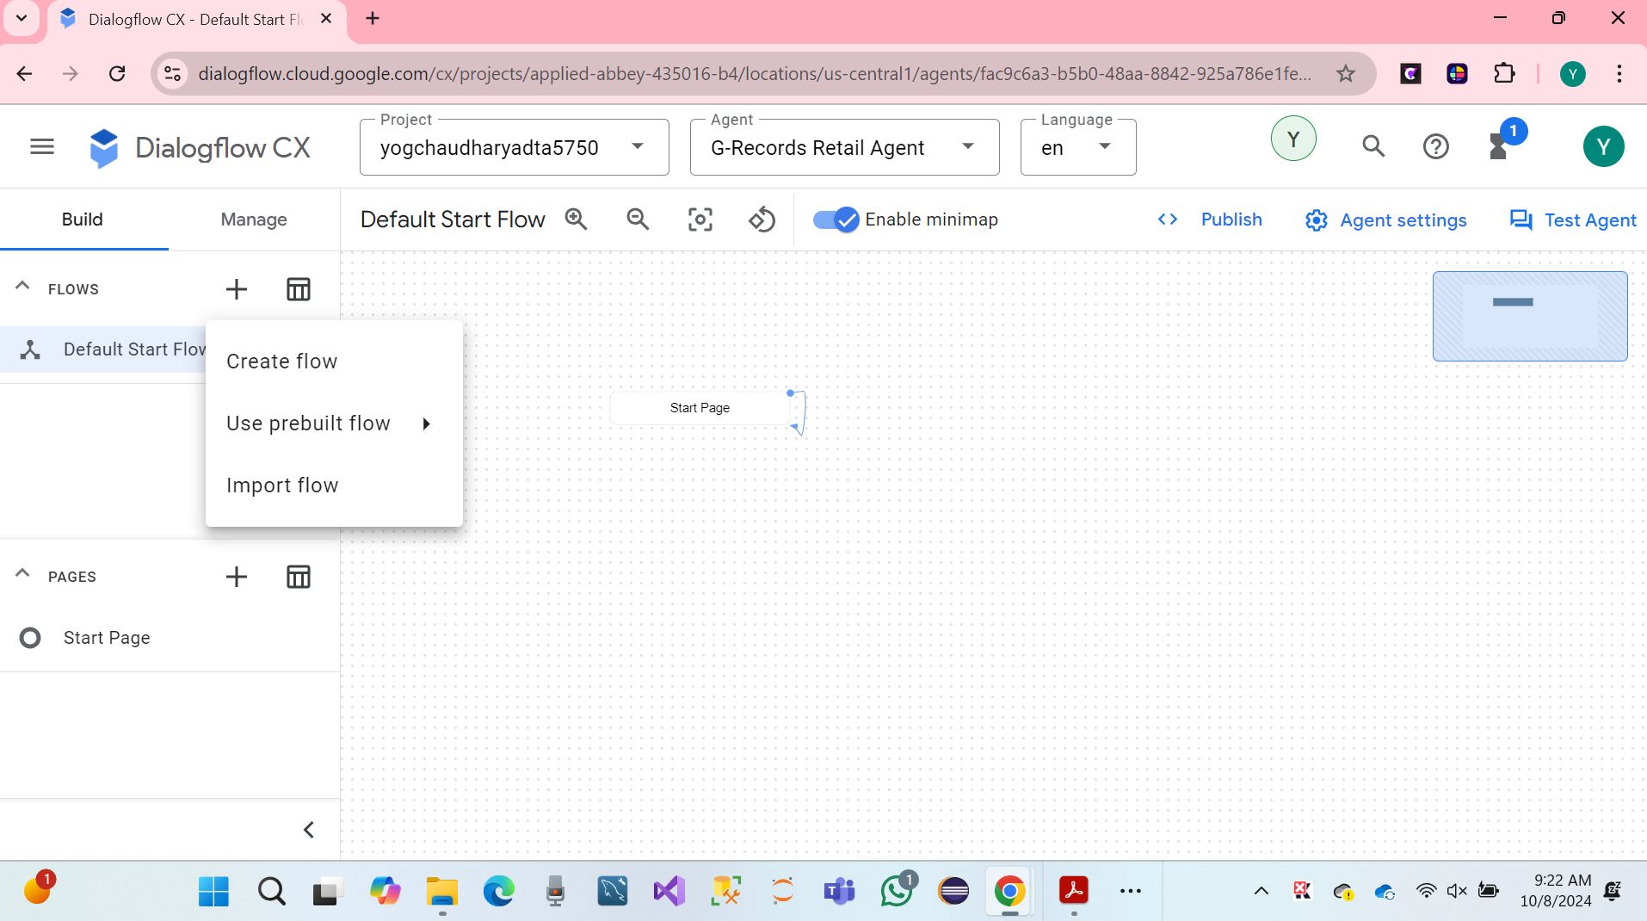

Next, we have flows has been created name of the following.

* **Catalog**
* **Order process**
* **My Order**
* **Customer Care**

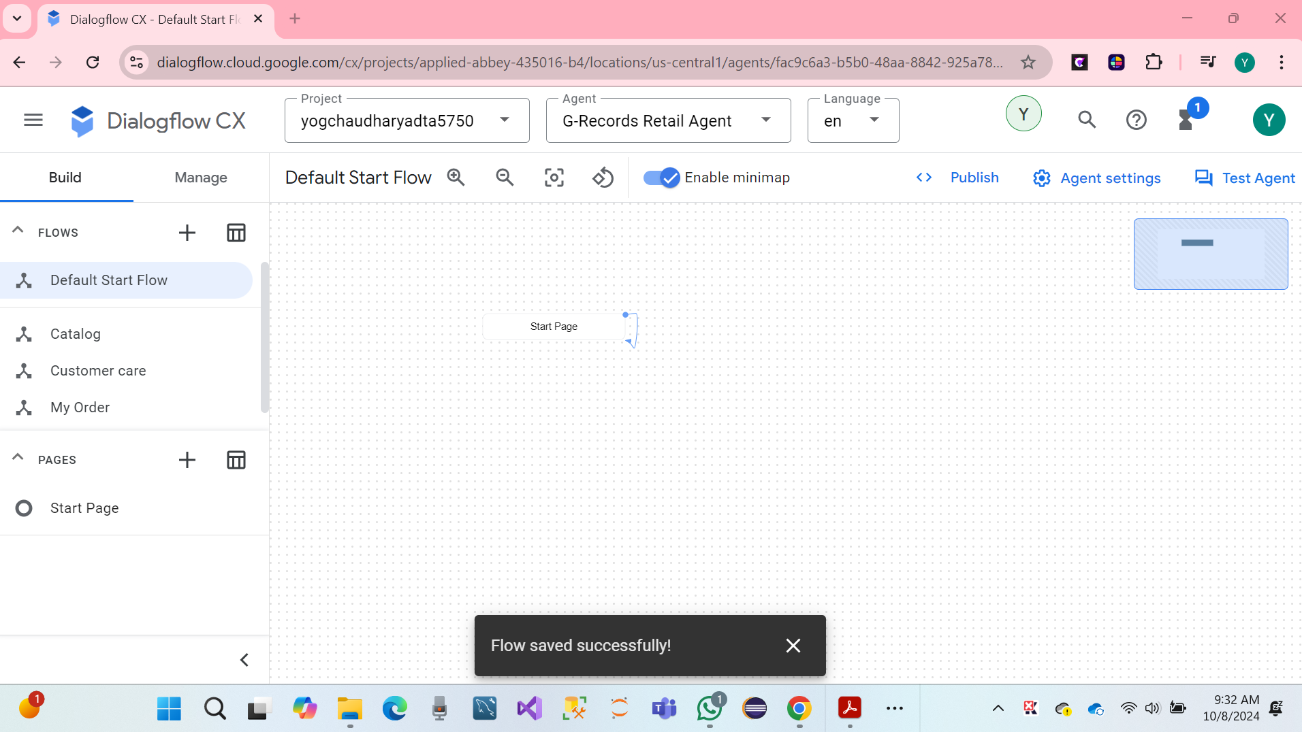

We have click on the Test Agent. Iin the talk to agent filed Write: Hello The virtual agent response with a default welcome text: Greetings! How can I assist?

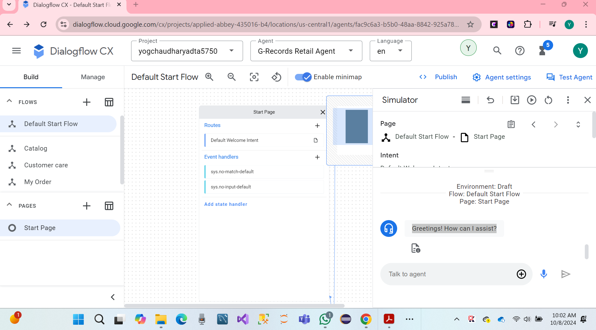

**# Default Start Flow**

We have start by creating an Intent Route, they will be triggered once you greet the virtual agent. Then, open the start page: It automatically selected the start Page, in the Build page section.

In Start: Routs click on the Default Welcome Intent.

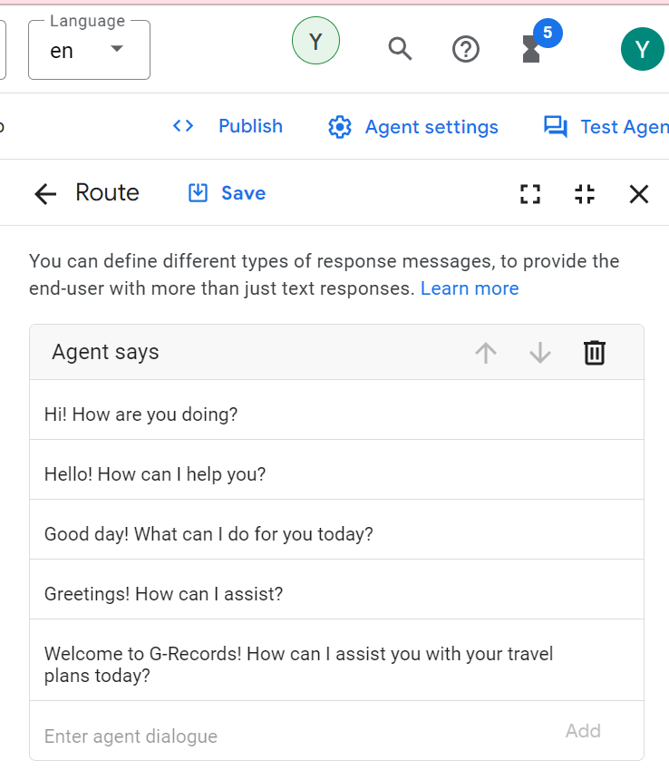

**We have removed all the agent says entries and add this new text.**

**Welcome, I am the virtual agent of G-Records, a fictional rock label. You can order artists merchandise, ask questions about your order or shipping, and I can tell you more which artists are currently signed with us. How can I help?**

* Click on the Route Save.
* Click on Add dialogue Operation, then choose Custom payload and sowing below code as a custom payload and hit save.

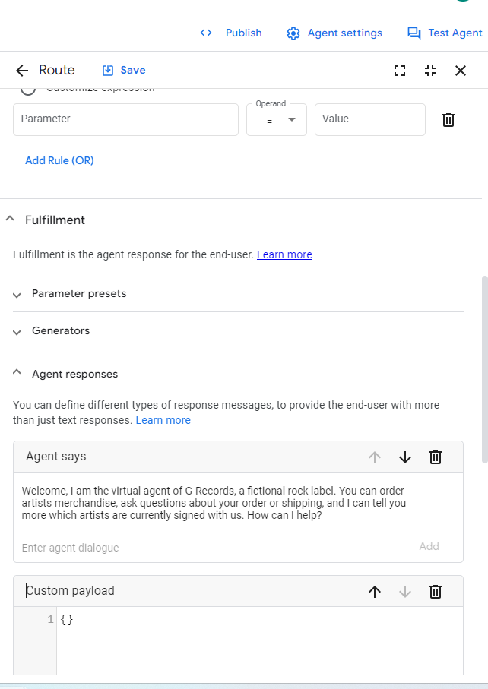

We have gone to the loft sidebar. Click on Manager select on the bar Integrations.

* Choose Dialogflow Messenger and click on connect. After that pop click Enable.

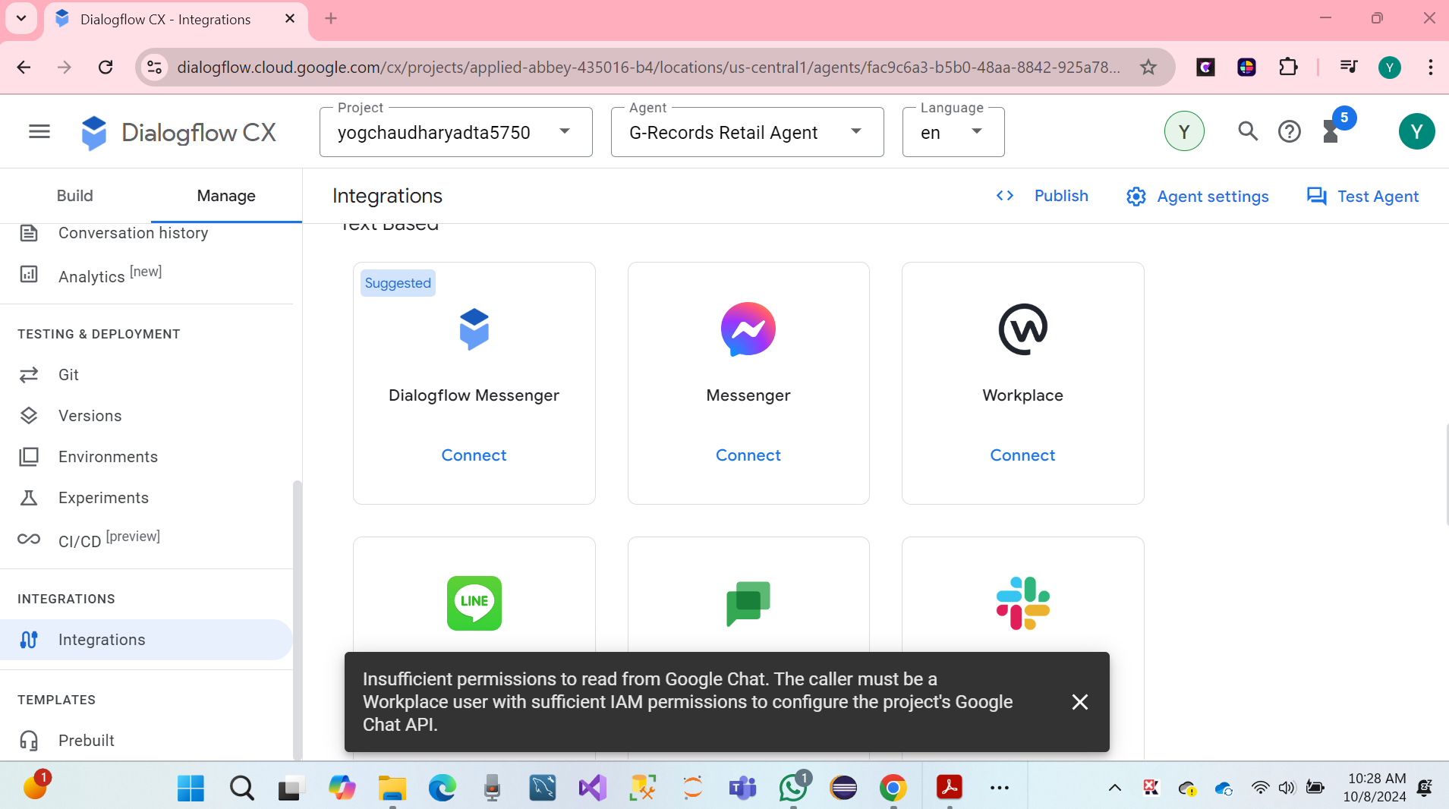

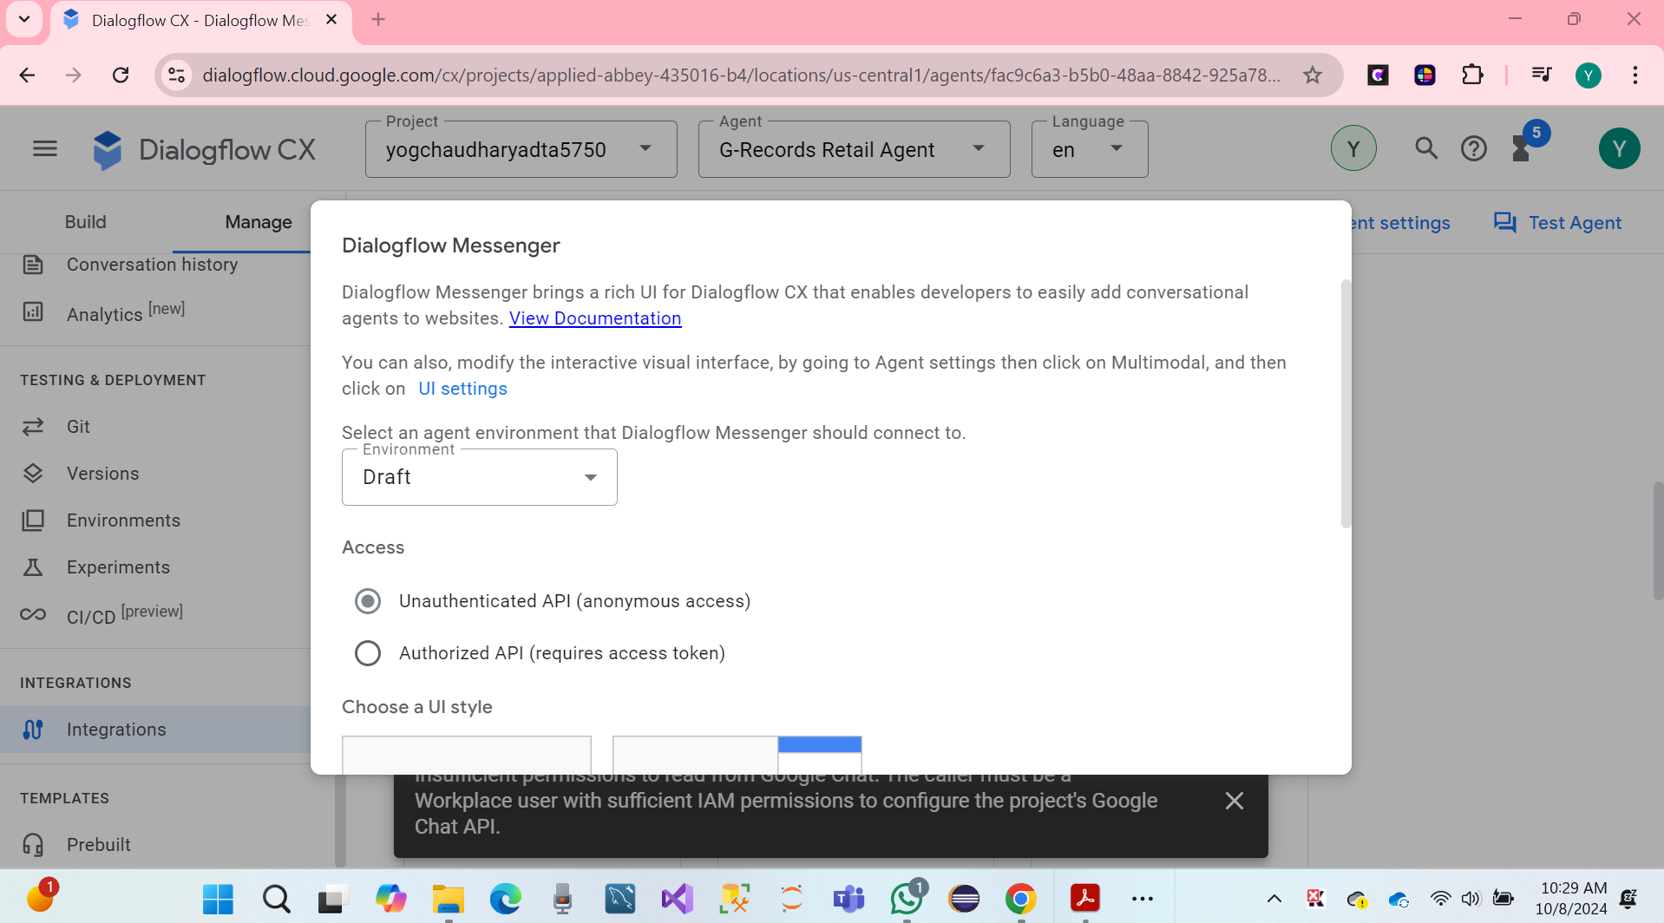

* We can see hare screen on the Dialogflow **Messenger**

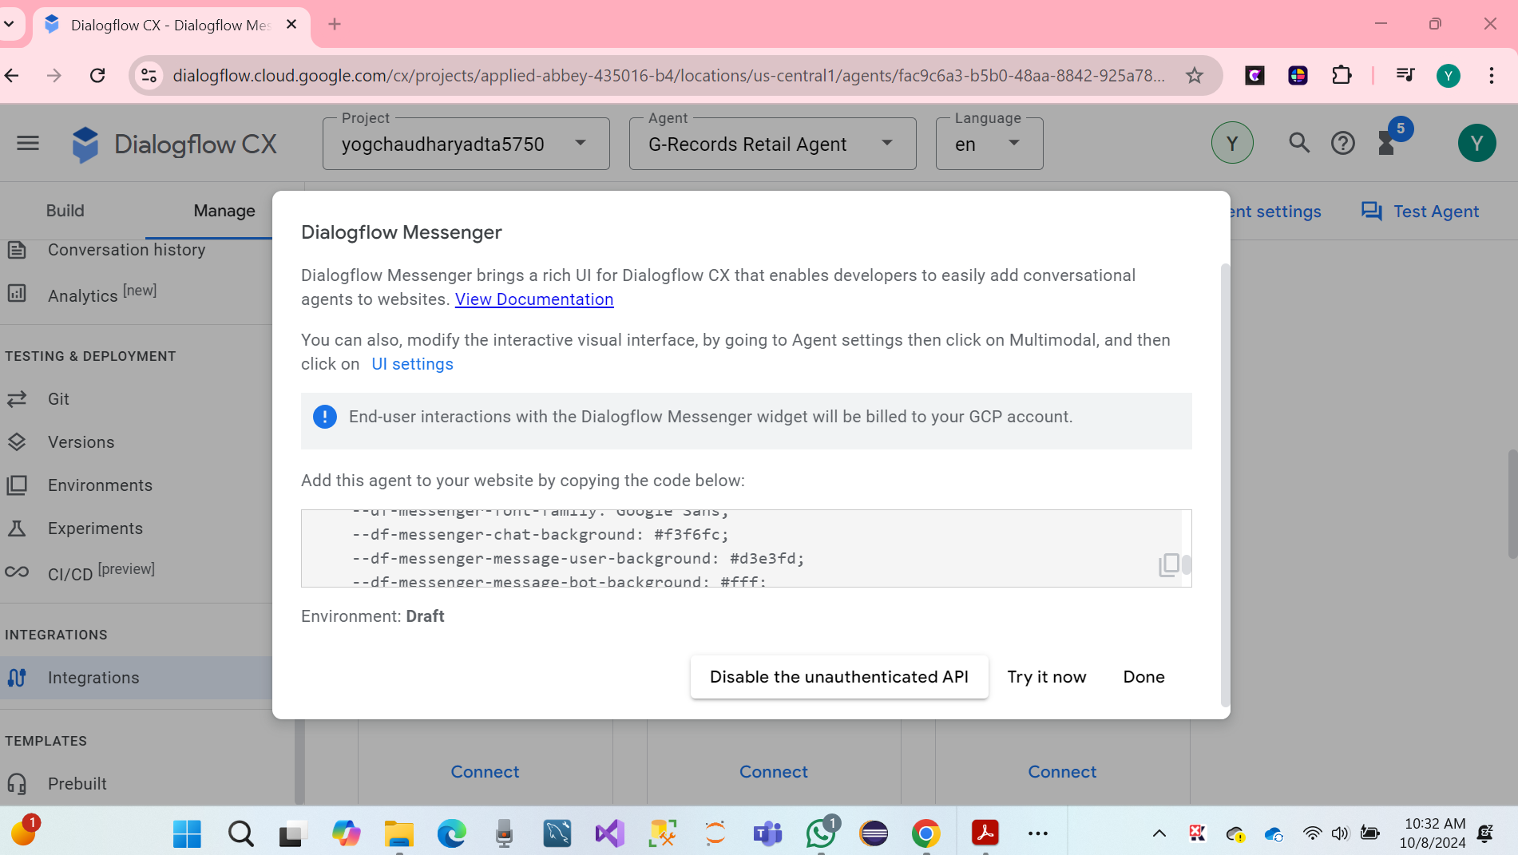

Finally, Successfully Flows, hare screenshot below

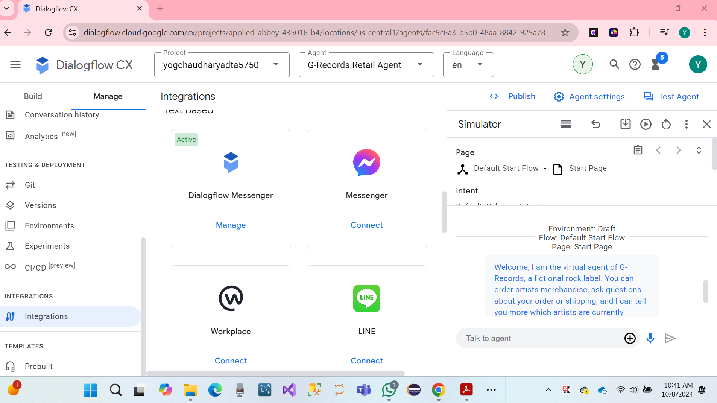

**TO-DO #3 Next, complete the steps to define entity types and entities for the conversational AI system.**

**Entity** represents key information extracted from user inputs in a conversation AI system. It objective related to the query. Entity provides details necessary to fulfill user request.

**For Example:** we created a retail system named **G- Records Retail Agent**. In entities included name merch, artist_1, album, Order Number, Shirt Size. These entities help the AI interpret user queries like (What is my Order, what is my T-shirt Size, and other entities). All entities identifying and extracting from user input allows the AI system to provide relevant responses, such as ordering tracking detail.

Entity several types for the conversation AI system for G Records retail Agents.

* Product Information.
* Order Information.
* Customer Support.
* Store Information.
* Feedback.

**First, we have created steps to define entity and Intent for the conversational AI system.**

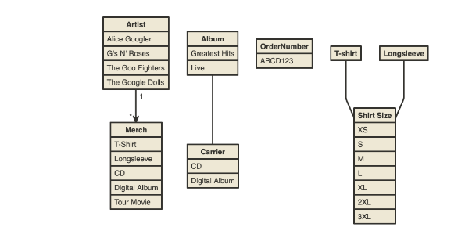

We have gone to the loft sidebar. Click on Manager select on the bar Entity types.

* Click on Create new.

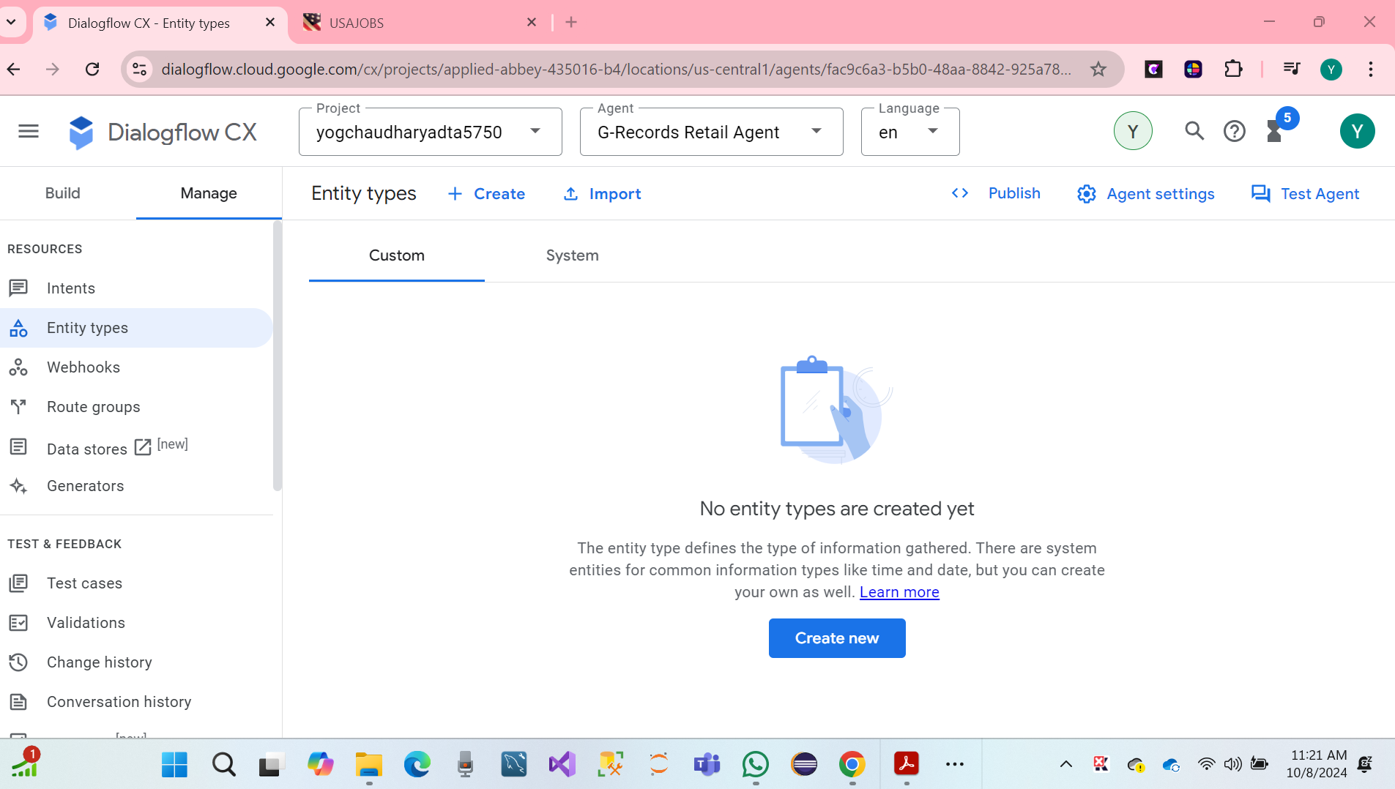

* Display Name of the Artist_1
* Entities.
* The Google Dolls (with synonym: Google Dolls)
* The Goo Fighters (with synonym: Goo Fighters)
* G's N' Roses (with synonym: Gs and Roses)
* Alice Googler

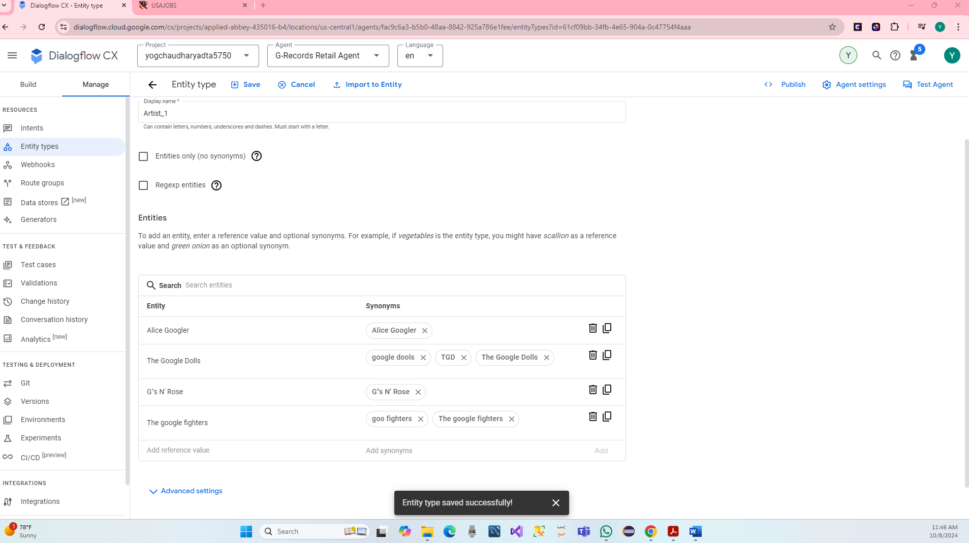

Again, Click on Create new.

* Display Name: Merch
* Entities:
* T-shirt
* Longsleeve (with synonym: Longsleeve shirt)
* Tour Movie
* Digital Album (with synonym: MP3 Album, MP3)
* CD (with synonyms Disc, Physical CD)

After that, Click on the Save.

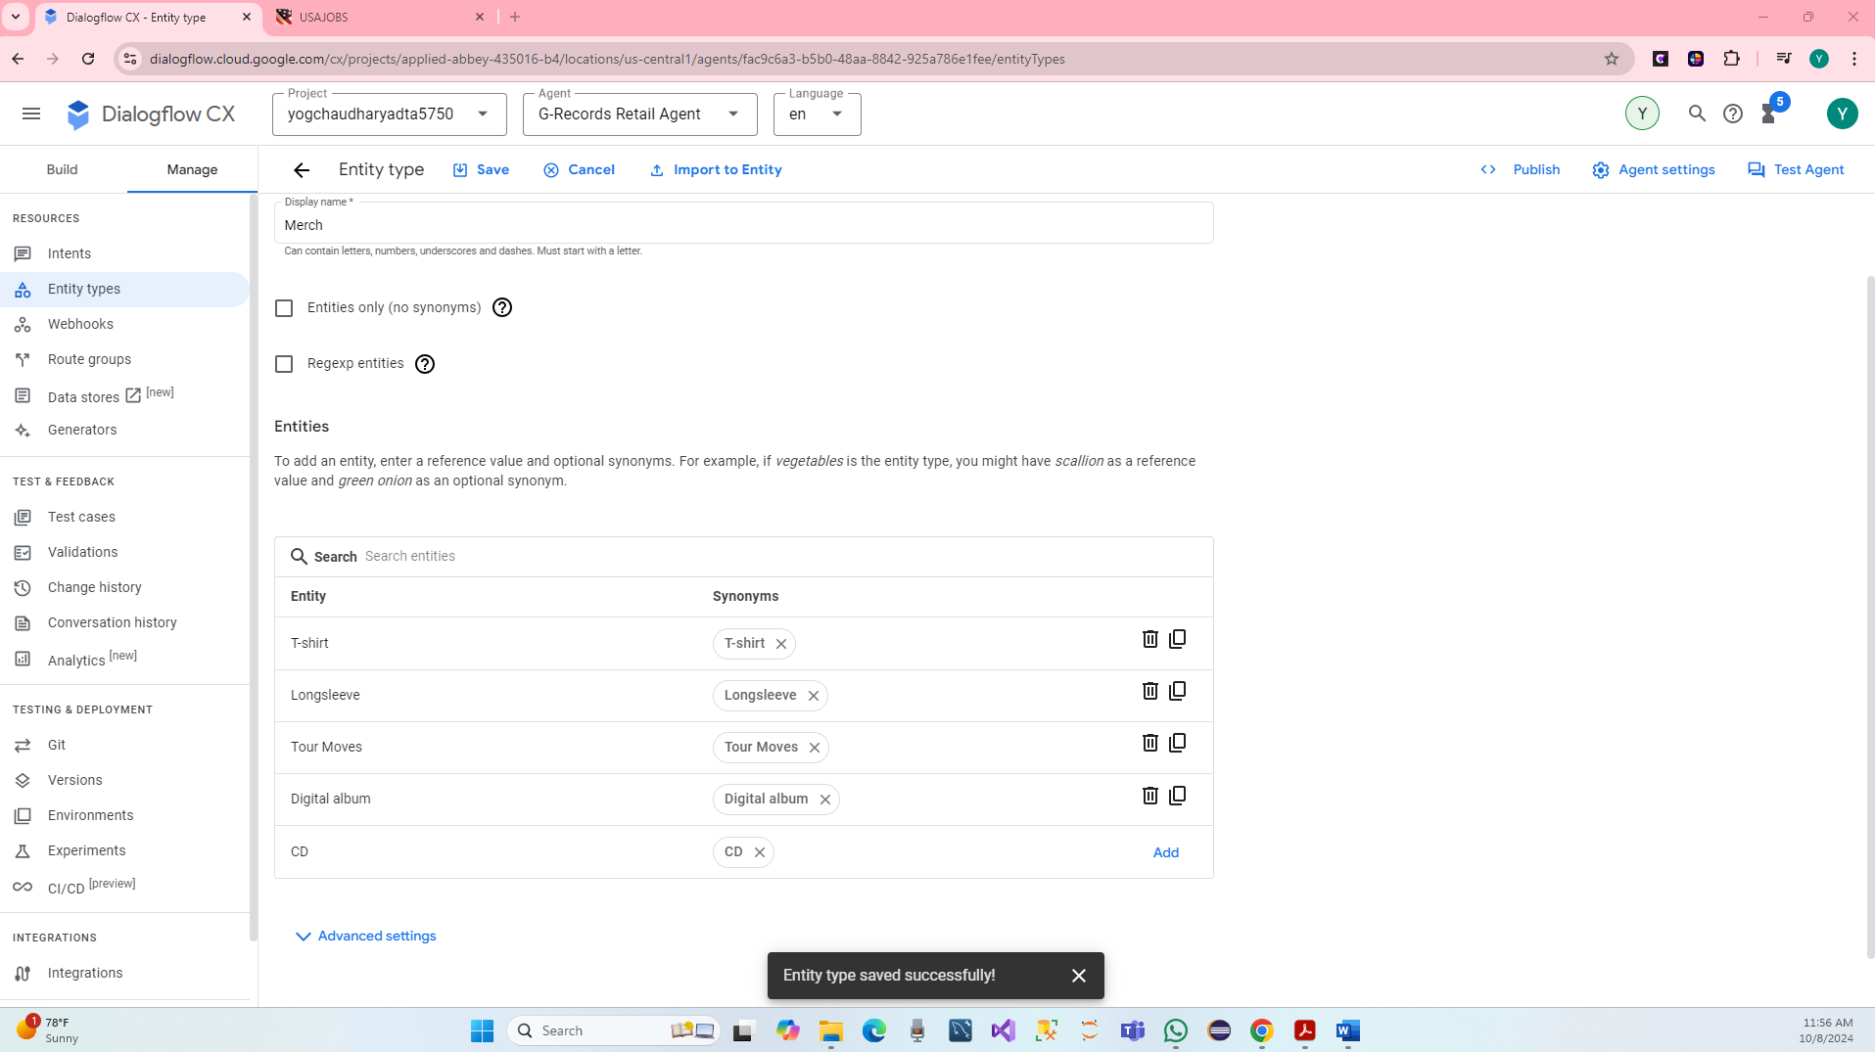

Again, Click on Create new.

* Display Name: Album
* Entities:
* Live
* Greatest Hits (with synonym: Hits)

Then, Click on the Save.

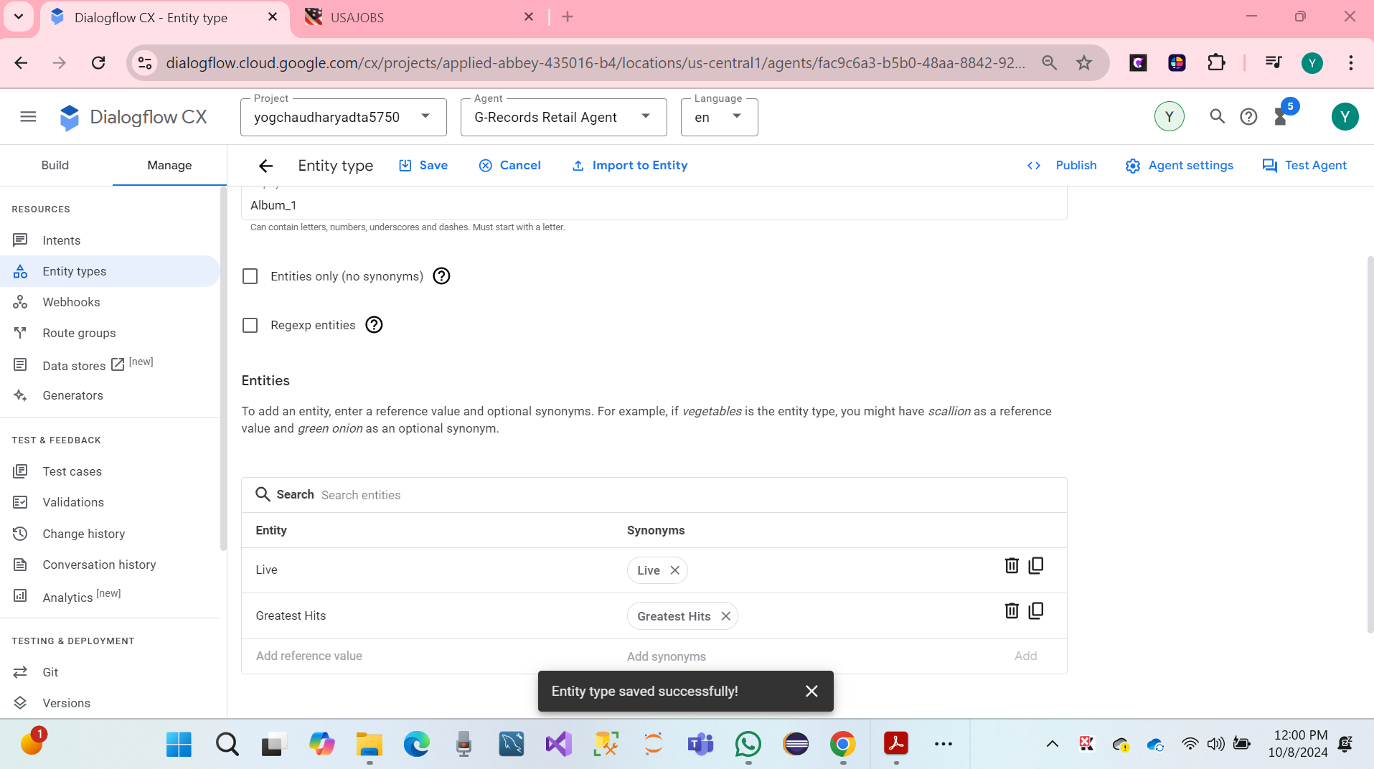

**Again, Click on Create new. Display Name: ShirtSize**

**Entities:**

* XS (with synonym: Extra Small)
* S (with synonym: Small)
* M (with synonym: Medium)
* L (with synonym: Large)
* XL (with synonym: Extra Large)
* 2XL (with synonym: Extra Extra Large)
* 3XL

Then, Click on the Save.

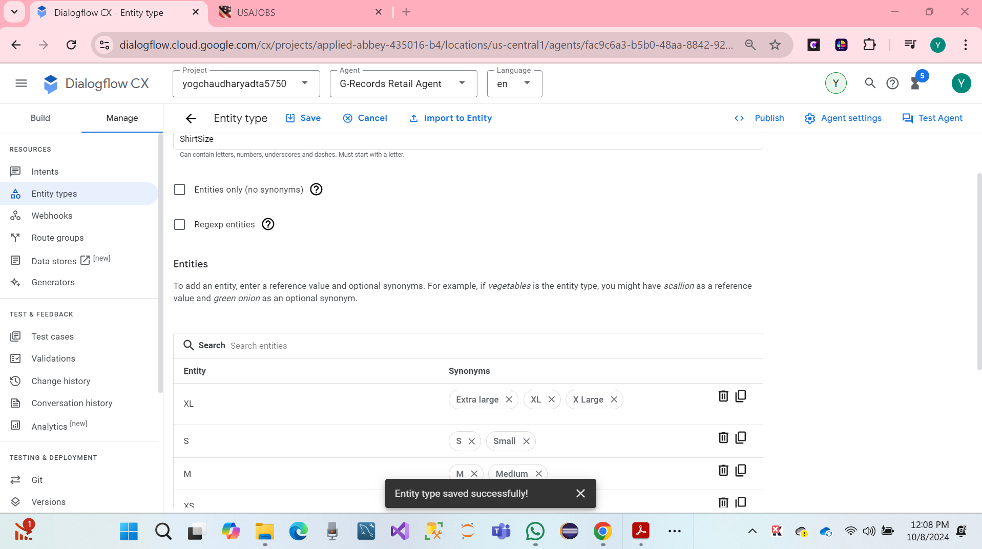

Again, Click on Create new. **Display Name:** OrderNumber

Regexp entities

* Entity: [A-Z]{4}[0-9]{3}

Then, Click on the Save.

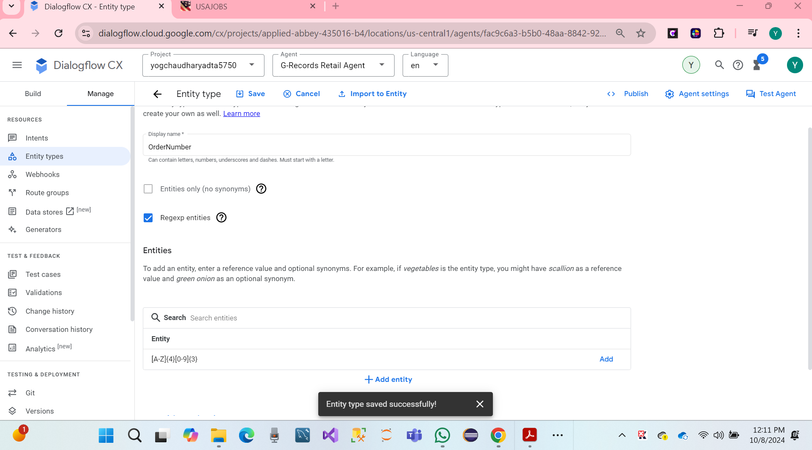

* We can see hare screen on the 5 Entity.

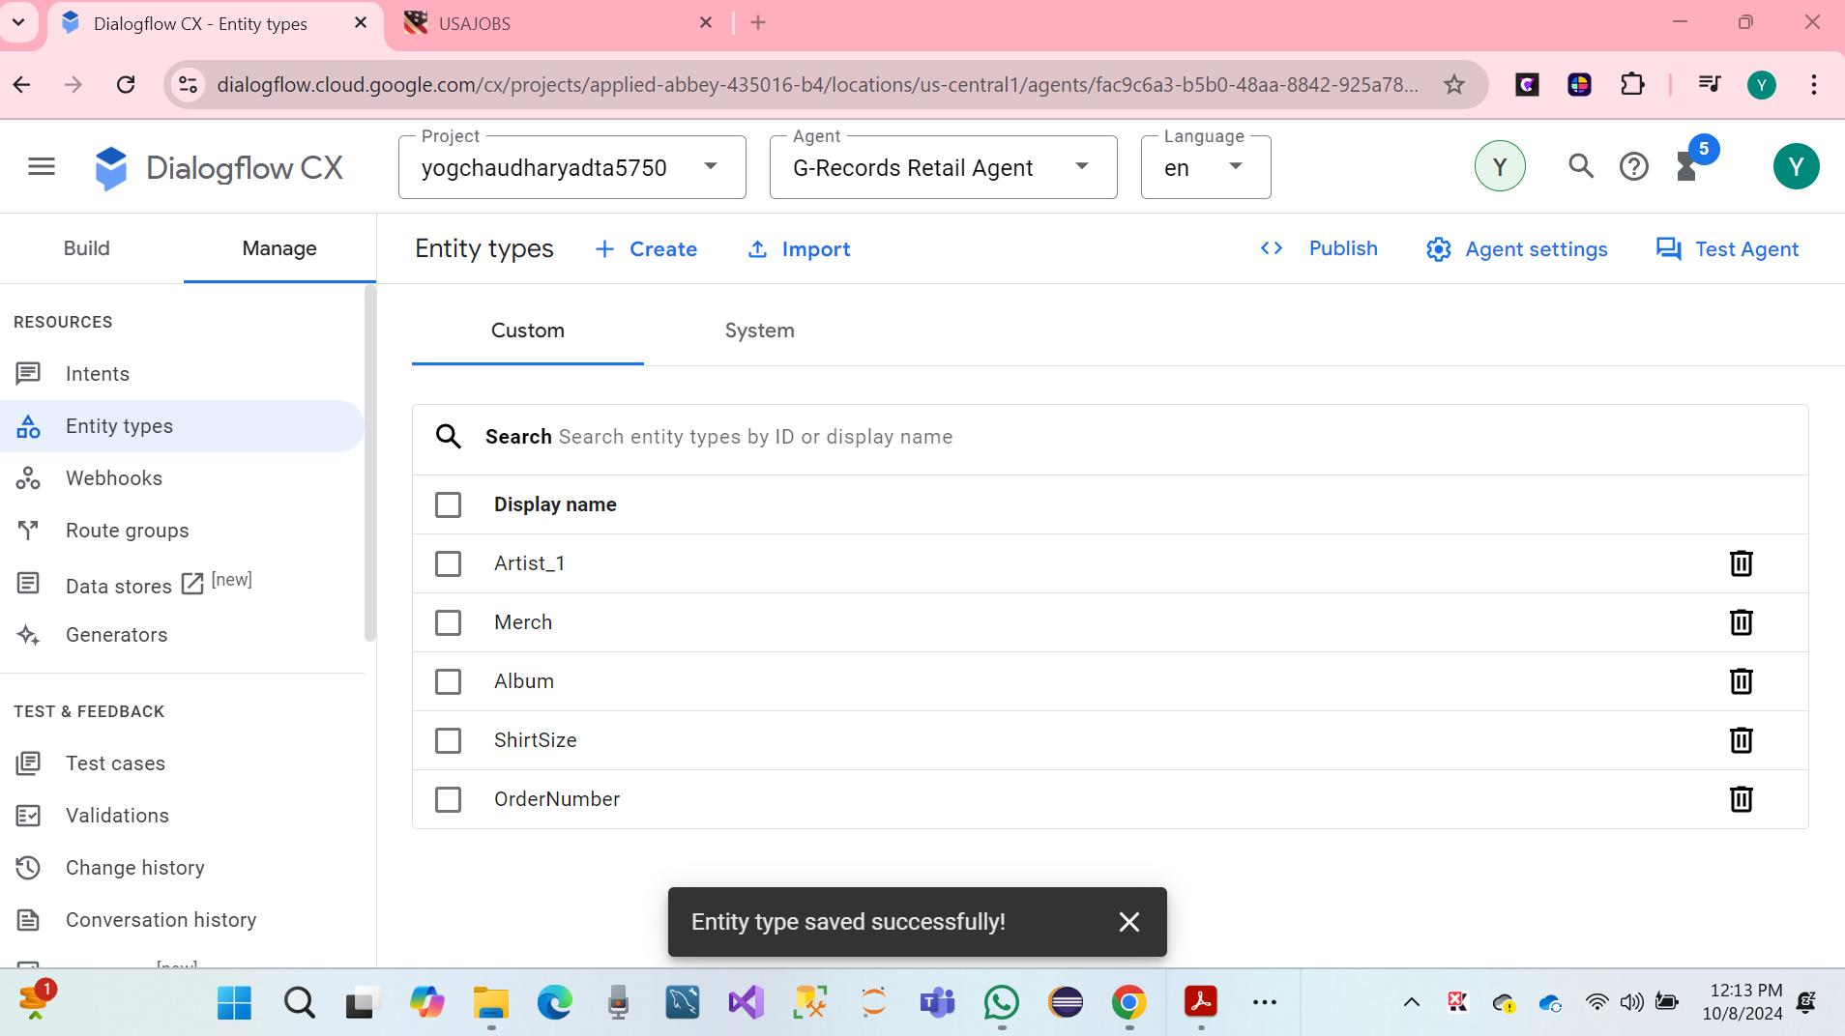

* Once, the custom entities are prepared, on the intents. Let's continue the lab.

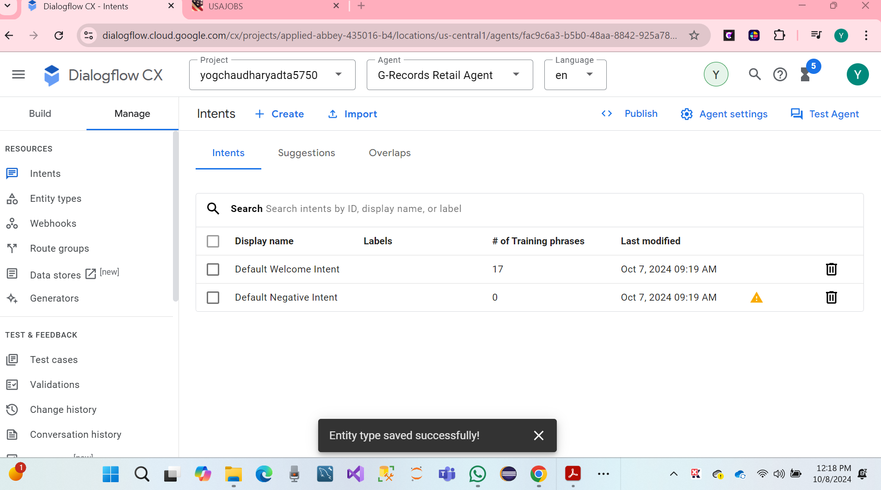

**TO-DO #4 Finally, complete the steps to add the intents for the conversation AI system.**

**Intents** for a conversational AI system involve identifying various goals that users want to achieve or the information they seek. This includes providing easy access to ordering information.

**We have to create Intents. Click on the manage on the select Intents. After that click on create.**

**Using the following details.**

* Display name redirect.artists.overview
* Description Artists overview: The bands supported by the label

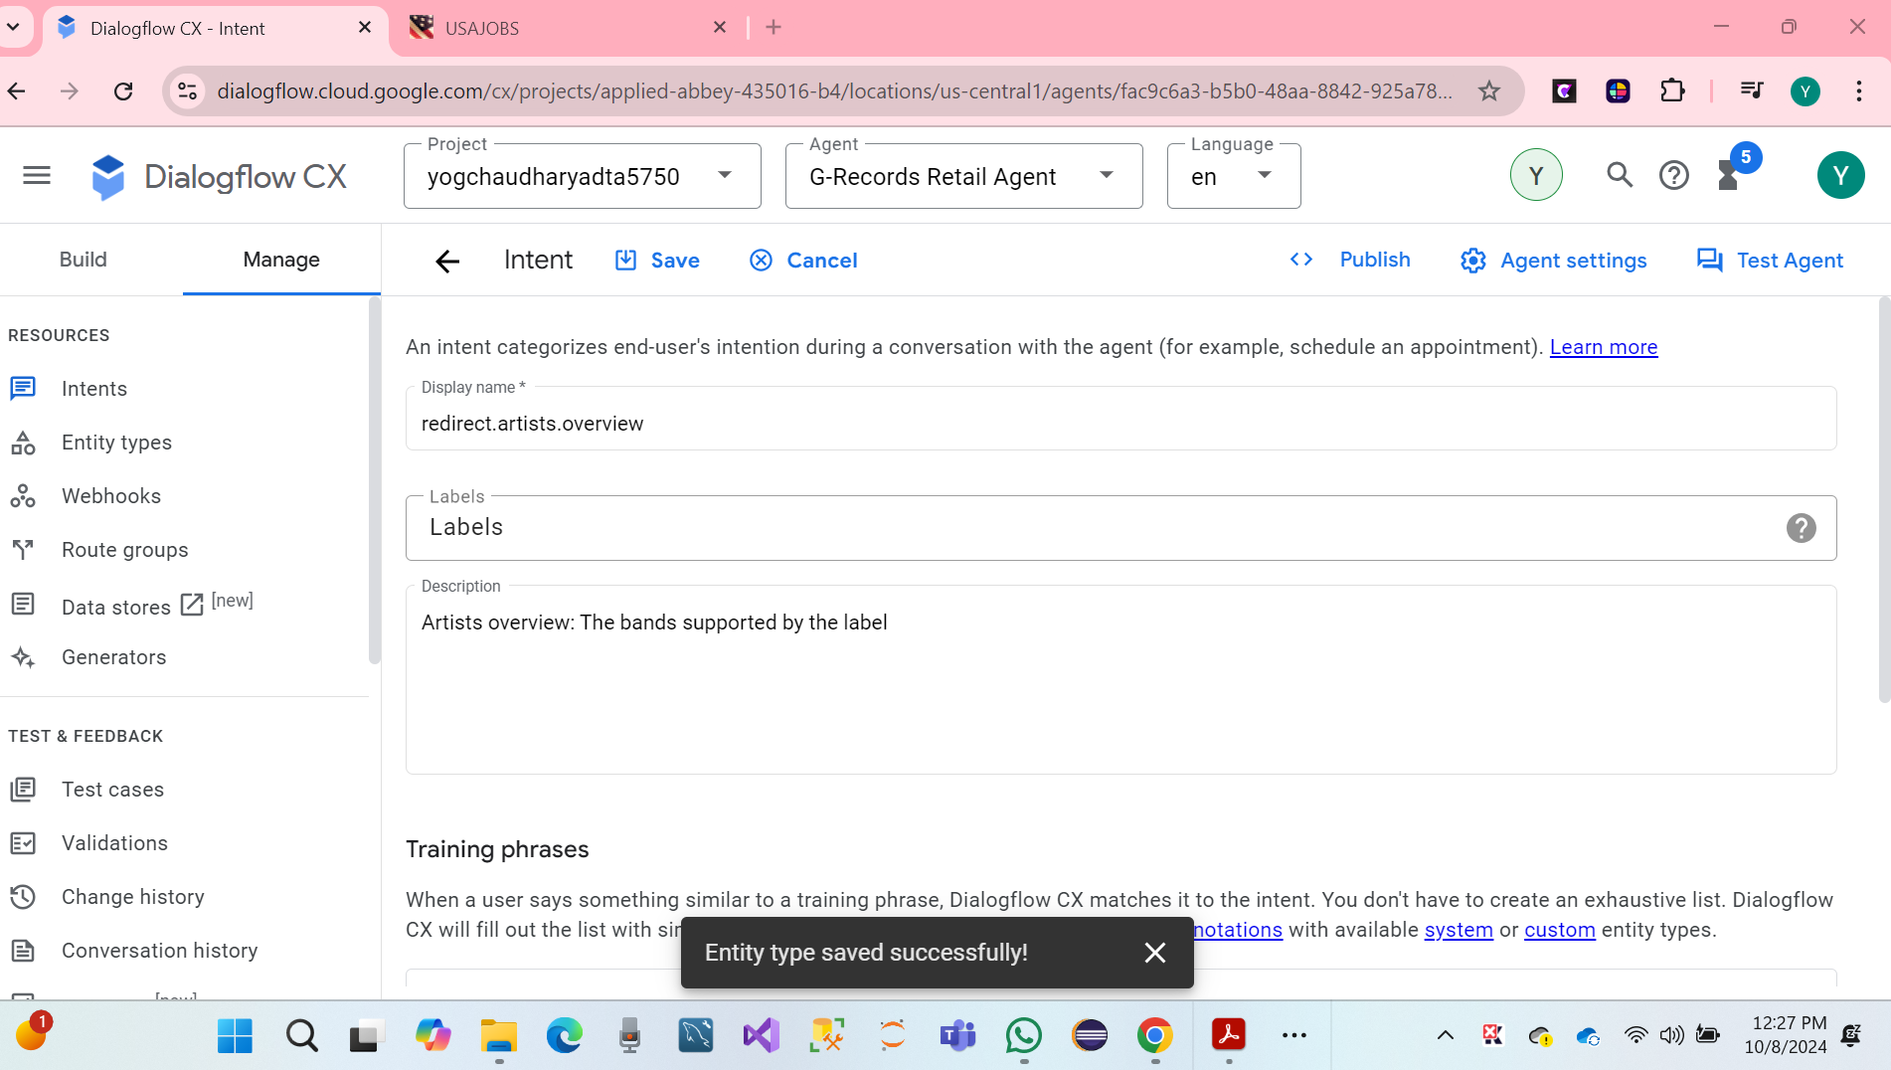

**We have created the following training phrases Intents:**

* Which bands are signed?
* Which bands
* Which artists
* Which artists are part of the record label
* Who is part of the label
* From which bands can I buy merchandise
* Band merchandise
* Which music do you have?
* I would like to know who are signed to the label
* Who are supported by the label
* From who can I buy shirts
* What music can I order
* Can I get an overview of all the artists

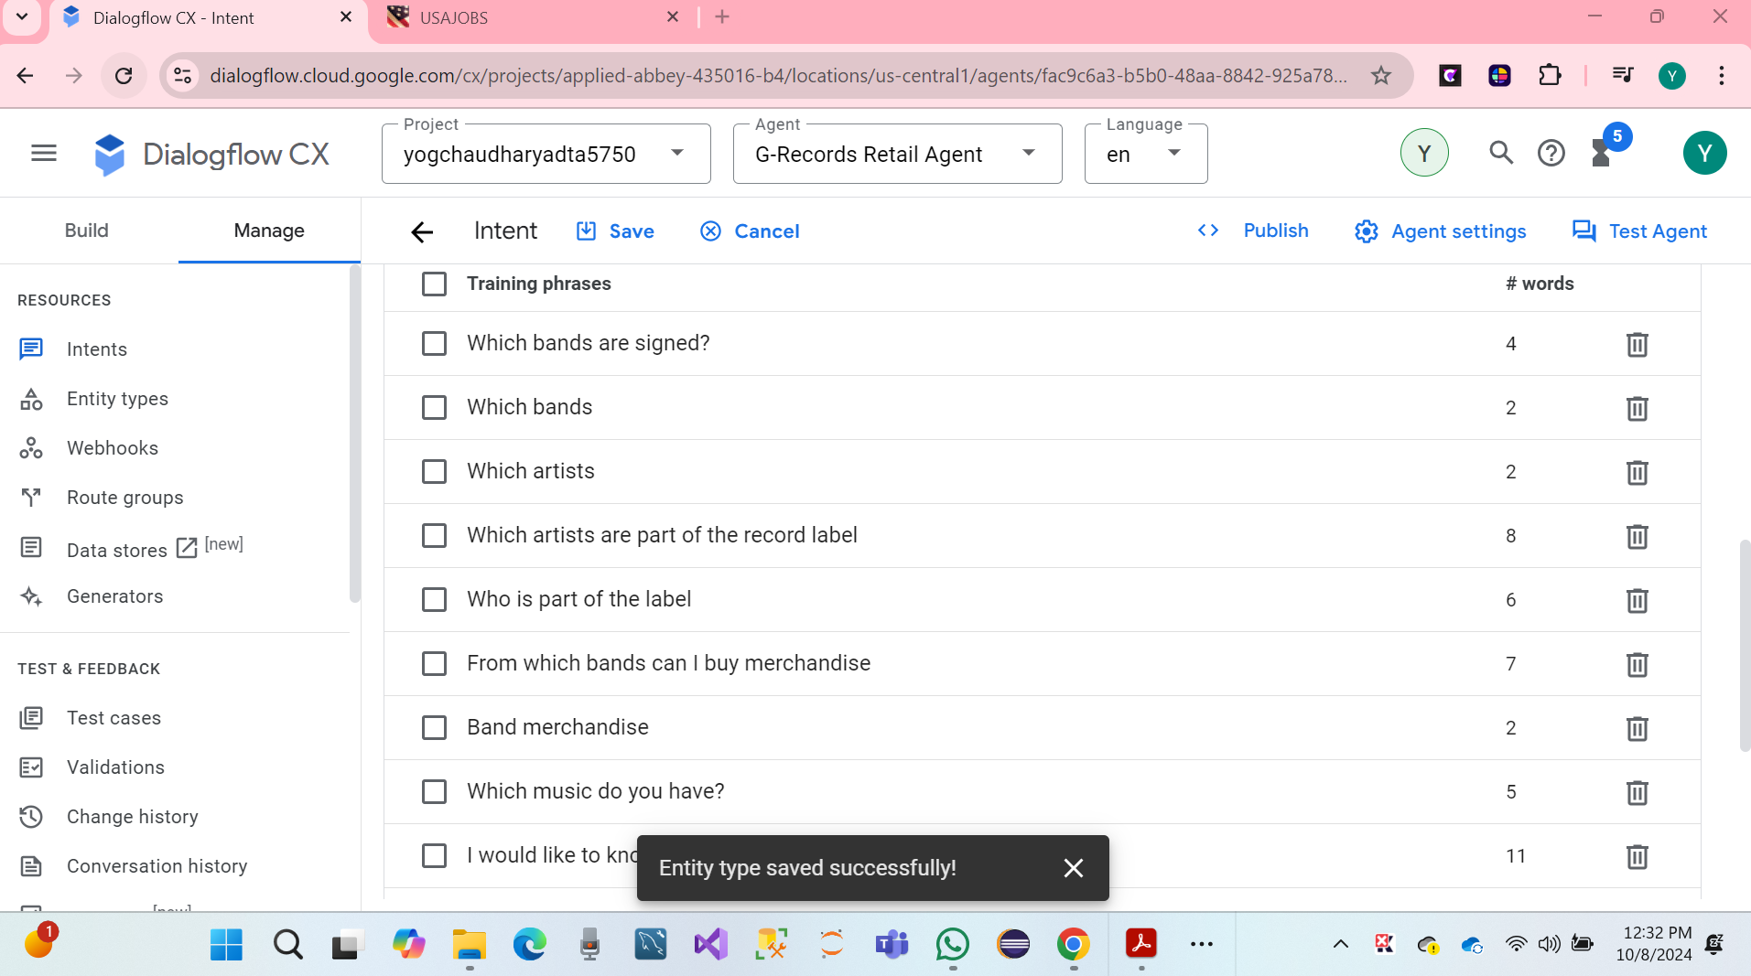

We have using following name of the conversation for page and Intents. All characters are lowercase, Intents using NLU to fetch a page Confirm/Decline for intents that confirm or decline choices, which can be come back at any monuments in the flow.

Added name of the **redirect.artists.overview** for Intents Screenshot hare .

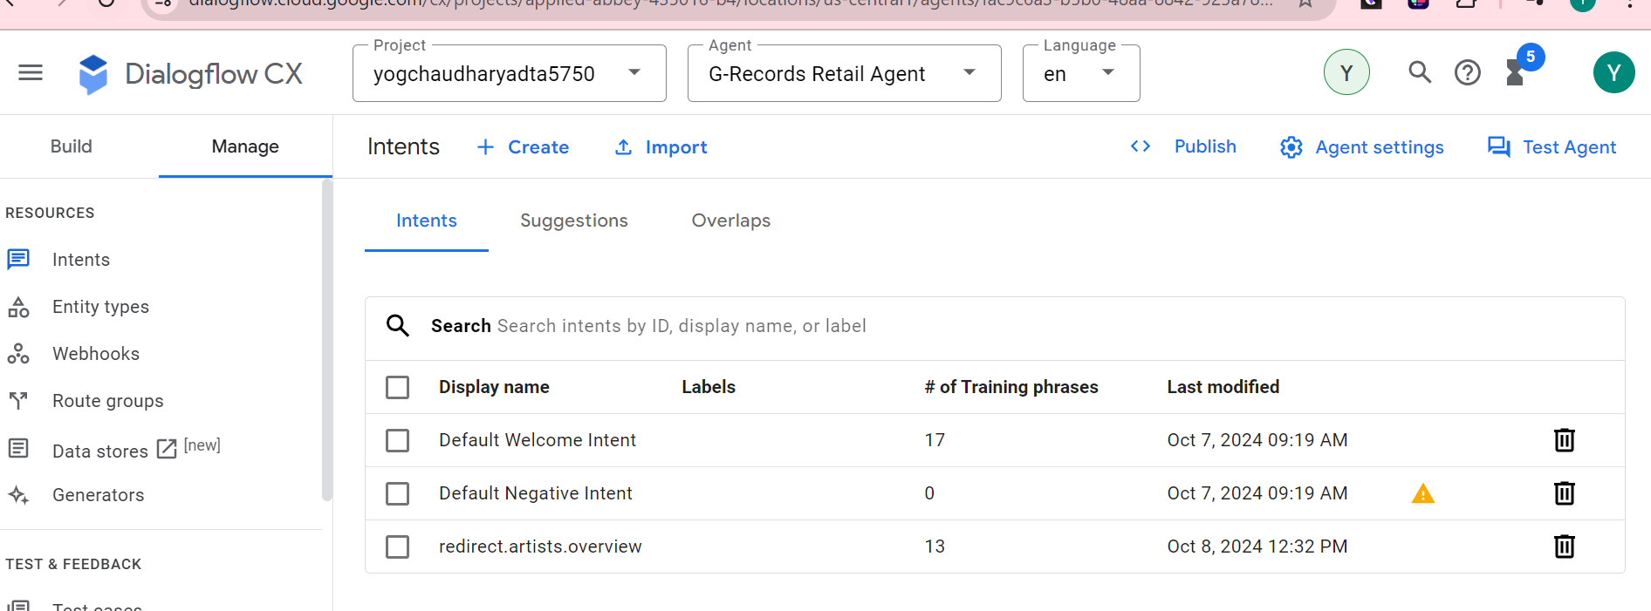

Again, Added or Created name of the **redirect.product.overview**for **Intents** Screenshot hare.

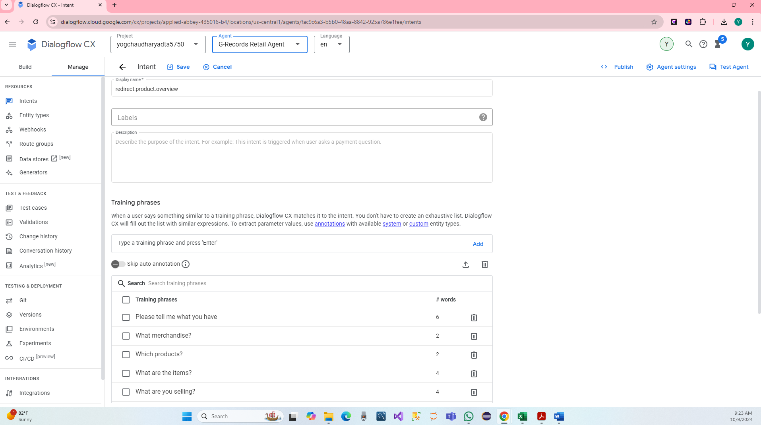

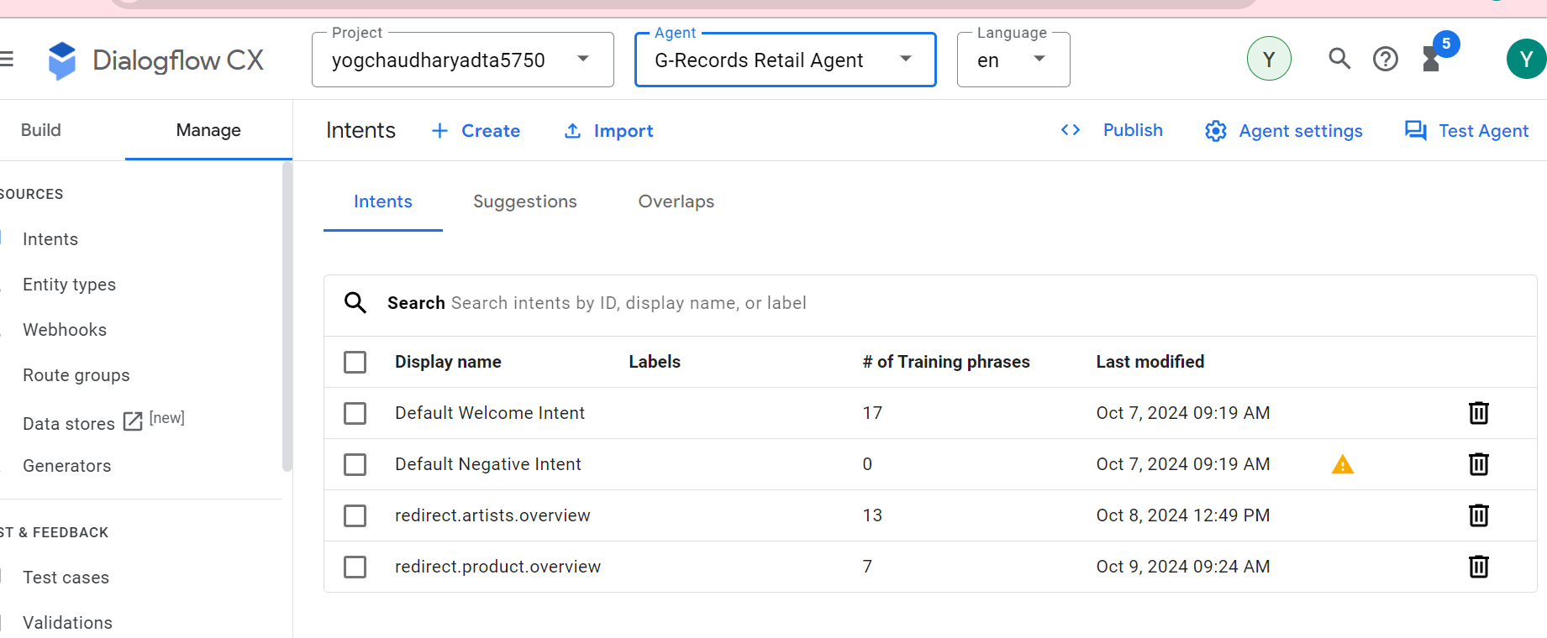

**Again, several types of the added training phrase, Dialogflow CX will automatically annotate intents.**

|  |  |
| --- | --- |
| **Display name** | **Training phrases** |
| **redirect.product.overview** | **"Which products do you sell?", "What merchandise items do you have?", "What are you selling?", "What are the items?", "Which products?" "What merchandise?", "Please tell me what you have"** |
| **confirm.artists.overview** | **"Yeah, let me buy merchandise", "Yes, I want to purchase something", "Yes, I would like to order merchandise from Alice Googler" *(Note: Alice Googler, should be recognized as an @Artist entity!)*, "Ok, let's buy stuff."** |
| **redirect.price** | **"How much does a t-shirt cost?", "What's the price for the tour movie?", "The album is how much?", "I want to know the price of a longsleeve shirt", "What's the price difference?", "What does each product costs?", "What does it cost?", "What is the price?"** |
| **redirect.product** | **"Tour movie", "I am interested in a t-shirt", "Can I buy a digital album?", "I want the CD", "I want to buy something", "Can I purchase a record?", "I want to buy a t-shirt size M of The Google Dolls", "Can I purchase the Alice Googler digital album?"** |
| **redirect.product.of.artist** | **"Yeah, let's shop", "Give me merch of Alice Googler", "Shirts of The Google Dolls that would be nice.", "Yes", "I want The Goo Fighters stuff", "Yes, I want to order merchandise", "Yep, give me items of G's N' Roses", "Go for it", "Anything Alice Googler", "I am a G's N' Roses fan!", "Google Dolls", "Yes of The Google Dolls"** |
| **redirect.shirts** | **"Shirts", "I want to buy shirts", "I am interested in shirts", "I want a shirt", "Shirts of G's N' Roses please", "Give me shirts of the Google Dolls", "I want to buy shirts of Alice Googler"** |
| **redirect.music** | **"Music", "I want to buy music", "I am interested in music", "Give me music of the Goo Fighters", "Music of Goo Fighters please", "Interested in buying the Alice Googler album", "Purchase Alice Googler music"** |
| **redirect.album** | **"Hits", "Live Album", "I want the Greatest Hits Digital Album", "Give me the Greatest Hits CD", "Hits on MP3"** |
| **redirect.shirt.size** | **"XS", "I have M", "I want Large", "My size is 3XL", "Extra Large is the size"** |
| **redirect.my.order** | **"About my order", "I have a question about my order", "My order is ABCD123, I have a question about my order."** |
| **redirect.my.order.status** | **My order is ABCD123, what is the status?", "What is the status of my order?", "What my order status?", "When will I receive my item?"** |
| **redirect.my.order.canceled** | **"I want to cancel my order", "I want to cancel order ABCD123", "Please cancel order ABCD123", "Undo my order", "Stop my order", "Cancel"** |
| **redirect.shipping.info** | **"How long will it take?", "How long is shipping?", "How long does shipping take?", "When will I receive it?"** |
| **redirect.refund.info** | **"I want a refund.", "Can I get a refund", "I want to return the CD", "I want to return my t-shirt"** |
| **redirect.swapping.info** | **"I want to swap my item", "Can I change my t-shirt for a larger size?", "Can I change my product?", "I want to swap the CD"** |
| **redirect.order.process** |  |
| **confirm.proceed.order** | **"Yes", "Yes, please continue", "Yes order", "I want to order", "Yeah", "Yep", "I confirm", "Agree", "Go ahead", "Order", "Buy it", "Purchase", "Okay"** |
| **decline.proceed.order** | **"No", "I rather not", "I don't want it anymore", "Don't order", "Stop", "Not anymore", "Nope", "Go back", "Reset", "Decline", "I don't need it"** |
| **redirect.home** | **"Go back", "Home", "Help", "What else can I ask", "Restart", "Can you tell me what I can order?", "What questions can I ask", "I need help", "Advice please", "Hi", "Hello", "Good day!"** |
| **redirect.end** | **"No that's it, goodbye", "Bye", "Cheers", "End", "That's it", "No more questions", "Exit", "Have a good day", "End Call", "Close"** |

**TO-DO #5 Write a report for each above task (TO-DO 1 – 4) with details about what has been done at each step, illustrated with the screenshots taken while working on each task.**

Reporting On Creating Virtual retail Agents for G-Records.

**We have to do 1,** We follow steps outlined in the tutorial to create a new virtual retail agent for G-Records, and I set the environment by creating a new project for the name virtual retail agent**.**

**We have to -do 2,** We follow steps to added to the conversational AI system, allowing for a structured conversation between users and the virtual retail agent.

**We have to -do 3,** Define types and entities. There are several types relevant to virtual retail agents, and diagrams have been created to visualize the relationship and characteristics of each entity.

**We have to -do 4,** we follow steps as listed all the intents required for the conversions AI system, enabling the virtual retail agent to understand and respond to user requests effectively.

**Overall summary:** The assignments 3 to create a virtual retail agent for G- record has progressed has easily through the initial phases of setting up the environment, adding dialog flows, defining entity types and entities, and integrating intents. The screenshots illustrate each step of the process, ensuring that the development is well-documented and transparent.

**7. PART IV: Teamwork Evaluation (10 Points)**

Provide the information about your group activities by answering the following questions:

**1. What group do you belong to? (Provide the group number)**

* I belong to Group 4

**2. Who are the members of your group?**

* **Namrata Sood**
* **Cynthia Ani**
* **Harika Ponugoti**
* **Akhila Karumudi**
* **Yog Chaudhary**

**3. Have the members organized any meeting (ONLINE or IN-PERSON) to see each other?**

* Yes, I have 5 members organized for an in-person class, and I have also organized a Zoom meeting.

**4. If YES to #3, which members, including the student himself/herself, showed up in the meeting?**

* Yes, The member name: **Namrata Sood**, **Harika Ponugoti**, **Akhila Karumudi**, Yog Chaudhary

**5. Have the members worked with each other on any class assignments?**

* I worked on class assignments separately, but all members have discussed and collaborated on projects related to the course on Natural Language Processing and machine learning.

**6. If YES to #5, do all the members make good efforts to actively participate in the group work?**

* Yes, all members make a strong effort to share knowledge to actively participate in the group 4.

**7. If NO to #5, do you have any opinions to share about the group?**

* No, I don’t have any opinions to share about the group regarding the **class assignments.**
* Most of discussion group project and relating machine learning, AI System Develop Conversations.

**References**

[**https://codelabs.developers.google.com/codelabs/dialogflow-cx-retail-agent#0**](https://codelabs.developers.google.com/codelabs/dialogflow-cx-retail-agent#0)

<https://codelabs.developers.google.com/codelabs/dialogflow-cx-retail-agent#9>

<https://www.youtube.com/watch?v=bpzSQTZ9MzI>

<https://www.youtube.com/watch?v=PGOWuHhi0Mg>